WEEK 3 Statistical Analysis and Predictive Modeling Using R
Introduction:
This week focuses on statistical analysis and predictive modeling using R. The cleaned Titanic dataset is used to examine relationships between passenger characteristics and survival. Hypothesis testing is performed to determine whether selected variables are significantly associated with survival. A classification model will then be developed to predict passenger survival, and its performance will be evaluated using suitable metrics.
Dataset and Target Variable
The Titanic dataset contains 891 passenger records. The target variable is Survived, where 0 represents passengers who did not survive and 1 represents passengers who survived. Variables such as passenger class, gender, age, family information and fare are used as predictors.
Exploratory Statistical Analysis
Descriptive Statistics:
Descriptive statistics are used to summarize the main characteristics of the numerical variables. Measures such as mean, median, minimum and maximum help understand the data before performing statistical tests and predictive modeling.
summary(data[, c(
"Survived",
"Pclass",
"Age",
"SibSp",
"Parch",
"Fare_capped"
)])
cat("Mean Age:", mean(data$Age, na.rm = TRUE), "\n")
cat("Median Age:", median(data$Age, na.rm = TRUE), "\n")
cat("Mean Fare:", mean(data$Fare_capped, na.rm = TRUE), "\n")
cat("Median Fare:", median(data$Fare_capped, na.rm = TRUE), "\n")
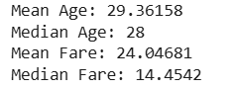
Correlation Analysis:
Correlation analysis is used to examine the strength and direction of linear relationships between numerical variables. Pearson correlation values range from -1 to +1. Values closer to zero indicate a weak linear relationship, while values closer to -1 or +1 indicate a stronger relationship.
cor_data <- data[, c(
"Survived",
"Pclass",
"Age",
"SibSp",
"Parch",
"Fare_capped"
)]
cor_matrix <- cor(
cor_data,
use = "complete.obs"
)
print(round(cor_matrix, 3))
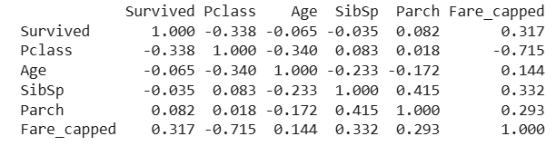
Normality Test
A normality test is performed to determine whether the distribution of a numerical variable approximately follows a normal distribution. The Shapiro-Wilk test is used for this purpose.
Hypotheses:
- H₀: The Age variable follows a normal distribution.
- H₁: The Age variable does not follow a normal distribution.
Result:
The Shapiro-Wilk test produced a W statistic of 0.9519 and a p-value of 1.102 × 10⁻¹¹. Since the p-value is less than the significance level of 0.05, the null hypothesis is rejected. Therefore, the Age variable does not follow a normal distribution.
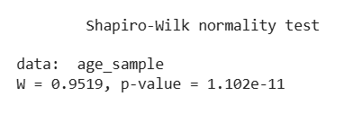

Hypothesis Testing
Chi-Square Test: Gender vs Survival
Hypotheses
H₀ (Null Hypothesis):Gender and survival are independent.
H₁ (Alternative Hypothesis):Gender and survival are significantly associated.
gender_table <- table(
data$Sex,
data$Survived
)
print(gender_table)
chi_gender <- chisq.test(gender_table)
print(chi_gender)
The Chi-square test produced a test statistic of 260.72 with 1 degree of freedom and a p-value less than 2.2 × 10⁻¹⁶. Since the p-value is much smaller than 0.05, the null hypothesis is rejected. Therefore, there is a statistically significant association between gender and survival among the passengers in the dataset.
Gender appears to be significantly associated with survival in the Titanic dataset.
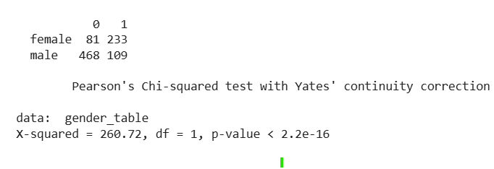
Predictive Modeling
Train-Test Split
The dataset was divided into training and testing sets using an 80:20 ratio. The training dataset contains 712 records, while the testing dataset contains 179 records. A random seed of 123 was used to make the split reproducible.
set.seed(123)
n <- nrow(data)
train_index <- sample(
1:n,
size = 0.8 * n)
train_data <- data[train_index, ]
test_data <- data[-train_index, ]
cat("Training rows:", nrow(train_data), "\n")
cat("Testing rows:", nrow(test_data), "\n")
Logistic Regression Model
Logistic regression was selected because the target variable Survived has two possible outcomes: 0 and 1. The model uses passenger class, gender, age, family information and fare to predict the probability of survival.
R code:
model <- glm(
Survived ~ Pclass + Sex + Age + SibSp + Parch + Fare_capped,
data = train_data,
family = binomial
)
summary(model)
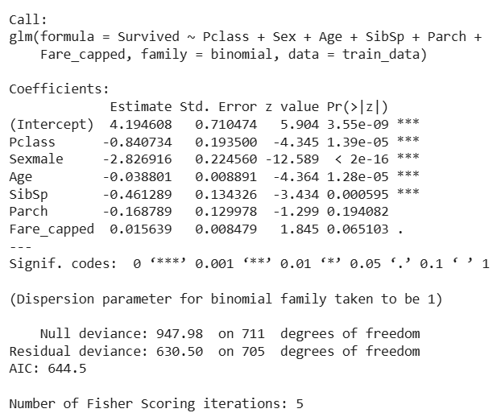
The logistic regression model was developed using Pclass, Sex, Age, SibSp, Parch, and Fare_capped as predictor variables. The results show that Pclass, Sex, Age, and SibSp have statistically significant effects on survival because their p-values are below 0.05. Parch is not statistically significant, while Fare_capped is also not significant at the 5% level. The negative coefficients for Pclass, SexMale, Age, SibSp and Parch indicate a decrease in the log-odds of survival as these variables increase or for the male category compared with the reference female category.
The model has a null deviance of 947.98 and residual deviance of 630.50. The AIC value is 644.5.

Model Predictions
After training the logistic regression model, predictions were generated for the test dataset. The model first calculates the probability of survival for each passenger. A threshold of 0.5 was used to convert these probabilities into binary predictions. A probability of 0.5 or higher is classified as survived (1), while a probability below 0.5 is classified as did not survive (0).
probabilities <- predict(
model,
newdata = test_data,
type = "response"
)
predictions <- ifelse(
probabilities >= 0.5,
1,
0
)
print(head(probabilities))
print(head(predictions))
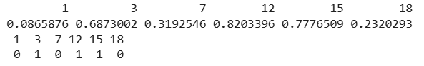
Confusion Matrix
A confusion matrix is used to compare the actual outcomes with the predicted outcomes of the classification model. It shows true positives, true negatives, false positives, and false negatives, which are used to calculate different model performance metrics.
actual <- test_data$Survived
confusion_matrix <- table(
Actual = actual,
Predicted = predictions)
print(confusion_matrix)
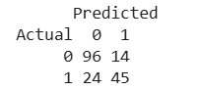
Model Performance Metrics
The logistic regression model was evaluated using accuracy, precision, recall, and F1-score. These metrics provide different measures of how well the model predicts passenger survival.
TN <- confusion_matrix[1,1]
FP <- confusion_matrix[1,2]
FN <- confusion_matrix[2,1]
TP <- confusion_matrix[2,2]
accuracy <- (TP + TN) / (TP + TN + FP + FN)
precision <- TP / (TP + FP)
recall <- TP / (TP + FN)
f1_score <- 2 * (precision * recall) / (precision + recall)
cat("Accuracy :", round(accuracy, 4), "\n")
cat("Precision:", round(precision, 4), "\n")
cat("Recall :", round(recall, 4), "\n")
cat("F1 Score :", round(f1_score, 4), "\n")
Metric | Result
Accuracy | 78.77%
Precision | 76.27%
Recall | 65.22%
F1-Score | 70.31%

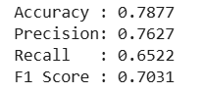
The logistic regression model achieved an accuracy of 78.77%, meaning that approximately 79% of the test observations were classified correctly. The precision was 76.27%, indicating that most passengers predicted as survivors were actually survivors. The recall was 65.22%, showing that the model correctly identified about 65% of the actual survivors. The F1-score was 70.31%, providing a balance between precision and recall. Overall, the model provided a reasonable level of predictive performance on the test dataset.
Model Diagnostics
Diagnostic Plots
Model diagnostic plots were used to examine the behavior of the logistic regression model and identify possible issues such as unusual observations, non-constant residual patterns, and influential points. Four diagnostic plots were generated: Residuals vs Fitted, Q-Q Residuals, Scale-Location, and Residuals vs Leverage.

par(mfrow = c(2, 2))
plot(model)
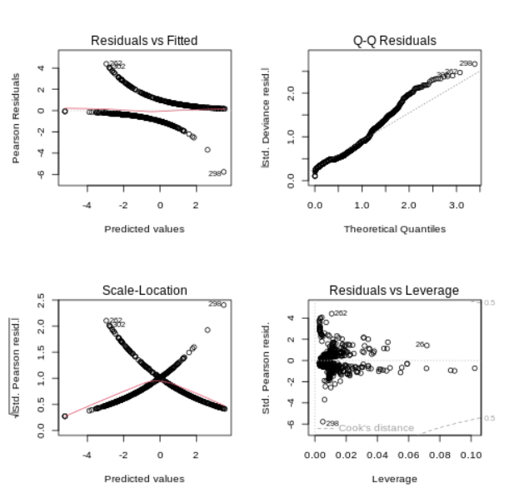
The Residuals vs Fitted plot shows the distribution of residuals across the fitted values and indicates some variation in the residual patterns. The Q-Q plot shows deviations from the reference line, suggesting that the residuals are not perfectly normally distributed. The Scale-Location plot shows variation in the spread of residuals across fitted values. The Residuals vs Leverage plot helps identify observations with relatively high leverage. Overall, the diagnostic plots indicate that the model has some limitations and that further feature engineering or alternative modeling techniques could potentially improve the predictions.

5-Fold Cross-Validation
5-fold cross-validation was used to check whether the logistic regression model performs consistently across different subsets of the dataset. The data was divided into five folds. In each iteration, four folds were used for training and the remaining fold was used for testing. This process was repeated five times, and the accuracy from each fold was recorded.
set.seed(123)
k <- 5
folds <- sample(
rep(1:k, length.out = nrow(data))
)
cv_accuracy <- numeric(k)
for (i in 1:k) {
cv_train <- data[folds != i, ]
cv_test <- data[folds == i, ]
cv_model <- glm(
Survived ~ Pclass + Sex + Age + SibSp + Parch + Fare_capped,
data = cv_train,
family = binomial
)
cv_prob <- predict(
cv_model,
newdata = cv_test,
type = "response"
)
cv_pred <- ifelse(
cv_prob >= 0.5,
1,
0
)
cv_accuracy[i] <- mean(
cv_pred == cv_test$Survived
)
}
print(cv_accuracy)
cat(
"Mean 5-Fold Cross-Validation Accuracy:",
round(mean(cv_accuracy), 4),
"\n"
)
The five folds produced accuracy values between 74.72% and 83.15%. The mean cross-validation accuracy was 78.56%. This is close to the test-set accuracy of 78.77%, indicating that the model provides reasonably consistent performance across different subsets of the data.
Key Findings
The statistical analysis and predictive modeling produced several important findings. The Chi-square test showed a statistically significant association between gender and survival. The logistic regression model identified Pclass, Sex, Age, and SibSp as statistically significant predictors at the 5% significance level. The model achieved an accuracy of 78.77%, precision of 76.27%, recall of 65.22%, and F1-score of 70.31% on the test dataset. These results show that the model provides reasonable predictive performance, although there is still scope for improvement.
Limitations and Possible Improvements
The model has some limitations, including the moderate recall and the presence of patterns in the diagnostic plots. The model could potentially be improved by using additional feature engineering, better handling of categorical variables, hyperparameter tuning, cross-validation, or comparing logistic regression with other classification algorithms such as decision trees, random forests, or support vector machines.
Conclusion
This analysis demonstrated the use of statistical testing and predictive modeling in R using the Titanic dataset. Hypothesis testing showed a significant relationship between gender and survival. Logistic regression was then used to predict survival using passenger characteristics. The model achieved 78.77% accuracy on the test data, showing reasonable predictive performance. Overall, the analysis demonstrates how statistical methods and machine learning can be combined to understand data and make predictions.
Complete Code
set.seed(123)
summary(data[, c(
"Survived",
"Pclass",
"Age",
"SibSp",
"Parch",
"Fare_capped"
)])
cat("Mean Age:", mean(data$Age, na.rm = TRUE), "\n")
cat("Median Age:", median(data$Age, na.rm = TRUE), "\n")
cat("Mean Fare:", mean(data$Fare_capped, na.rm = TRUE), "\n")
cat("Median Fare:", median(data$Fare_capped, na.rm = TRUE), "\n")
cor_data <- data[, c(
"Survived",
"Pclass",
"Age",
"SibSp",
"Parch",
"Fare_capped"
)]
cor_matrix <- cor(
cor_data,
use = "complete.obs"
)
print(round(cor_matrix, 3))
age_sample <- sample(
data$Age,
min(500, length(data$Age))
)
shapiro_result <- shapiro.test(age_sample)
print(shapiro_result)
gender_table <- table(
data$Sex,
data$Survived
)
print(gender_table)
chi_gender <- chisq.test(gender_table)
print(chi_gender)
n <- nrow(data)
train_index <- sample(
1:n,
size = 0.8 * n
)
train_data <- data[train_index, ]
test_data <- data[-train_index, ]
cat("Training rows:", nrow(train_data), "\n")
cat("Testing rows:", nrow(test_data), "\n")
model <- glm(
Survived ~ Pclass + Sex + Age + SibSp + Parch + Fare_capped,
data = train_data,
family = binomial
)
summary(model)
probabilities <- predict(
model,
newdata = test_data,
type = "response"
)
predictions <- ifelse(
probabilities >= 0.5,
1,
0
)
print(head(probabilities))
print(head(predictions))
actual <- test_data$Survived
confusion_matrix <- table(
Actual = actual,
Predicted = predictions
)
print(confusion_matrix)
TN <- confusion_matrix[1,1]
FP <- confusion_matrix[1,2]
FN <- confusion_matrix[2,1]
TP <- confusion_matrix[2,2]
accuracy <- (TP + TN) / (TP + TN + FP + FN)
precision <- TP / (TP + FP)
recall <- TP / (TP + FN)
f1_score <- 2 * (precision * recall) / (precision + recall)
cat("Accuracy :", round(accuracy, 4), "\n")
cat("Precision:", round(precision, 4), "\n")
cat("Recall :", round(recall, 4), "\n")
cat("F1 Score :", round(f1_score, 4), "\n")
par(mfrow = c(2, 2))
plot(model)
set.seed(123)
k <- 5
folds <- sample(
rep(1:k, length.out = nrow(data))
)
cv_accuracy <- numeric(k)
for (i in 1:k) {
cv_train <- data[folds != i, ]
cv_test <- data[folds == i, ]
cv_model <- glm(
Survived ~ Pclass + Sex + Age + SibSp + Parch + Fare_capped,
data = cv_train,
family = binomial
)
cv_prob <- predict(
cv_model,
newdata = cv_test,
type = "response"
)
cv_pred <- ifelse(
cv_prob >= 0.5,
1,
0
)
cv_accuracy[i] <- mean(
cv_pred == cv_test$Survived
)
}
print(cv_accuracy)
cat(
"Mean 5-Fold Cross-Validation Accuracy:",
round(mean(cv_accuracy), 4),
"\n"
)

